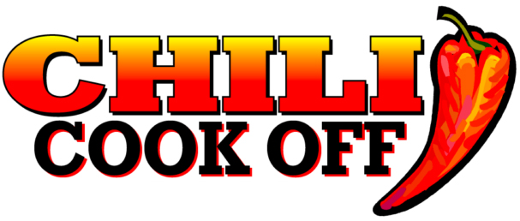
Idaho City Chamber of Commerce

March 4, 2023 Idaho City, Idaho
Idahocitychamber.org, PO Box 507, Idaho City, ID 83631

Sponsorship Sign-Up
Sponsors may also sign-up and pay online at idahocitychamber.org/chili-cook-off

Name of Business_____________________________________________
Name of Contact, Title________________________________________
Address________________________________________________________
Phone_____________________________Email________________________
Sponsorship Level______________________________________________
All levels include:
- Chili Cook-Off Team Entry Fees waived for one Team ($40 value)
- Facebook ad and bulletin board recognition at the event.
- 1 Commemorative bowl, each with raffle and People’s Choice voting ticket.
- Space at the Sponsors’ Table to display literature.

EVENT SPONSOR – Contact boardmembers@idahocitychamber.org
Requires a 50/50 Chamber/Sponsor Cash Match
Gold Level – Habanero - $500 (Scoville heat index: 150,000 plus)
Additional: Mention in all advertising possible in print and online, and space for one banner on a wall or vehicle (you provide) parked at the entrance of the event. Mentioned in the Idaho World as a Gold Level Sponsor.
Silver Level – Serrano - $250 (Scoville Heat Index: 10,000 plus)
Additional: Mention in the Idaho World, as a Silver Level Sponsor
Bronze Level – Jalapeno - $100 (Scoville Heat Index: 2,000 plus)

- Many businesses who enter the contest choose to be a sponsor too, as an additional show of support, since their entry fee is included in all Sponsor levels.
- Sponsors who don’t enter, may choose to donate their entry fee to a contestant who requests help with covering their entry fees. That contestant may compete in the sponsor’s name.

